Paula De Francisco Pérez  Brand & Marketing · E-Commerce · Key Account Management · Trade Marketing | FMCG · Beauty · Fashion  Dubai, UAE | +971 50 386 3656 | paulich98@hotmail.com  https://www.linkedin.com/in/paula-de-francisco-perez-92a13119a/ | Portfolio: paula-de-francisco.vercel.app | Nationality: Spanish | UAE Employment Visa (employer-sponsored) | 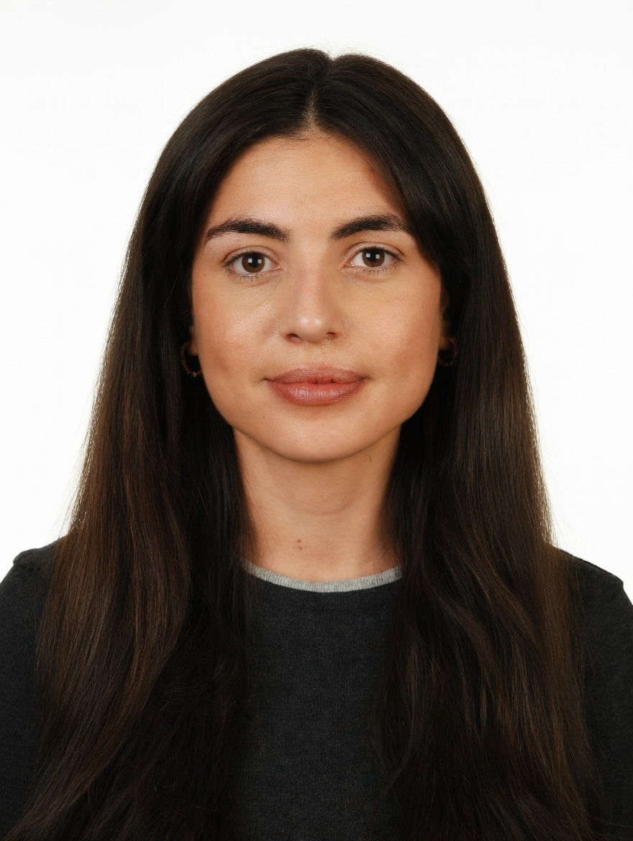
PROFESSIONAL SUMMARY

Brand, e-commerce and commercial professional with 5 years across FMCG, beauty and fashion. Brand & Marketing Manager at DoFreeze in Dubai, leading a team of two across 50+ markets; previously grew 42 beauty and fashion brands +30% GMV QoQ at Alibaba's Miravia.
WORK EXPERIENCE

Brand & Marketing Manager | Oct 2025 – Present
DoFreeze LLC · UAE F&B / FMCG group | Befit, Eurocake, Flair | sold in 50+ countries · Dubai, UAE
• Lead brand and marketing across 50+ markets with a team of two (designer, social media exec); led 6 NPD launches end-to-end (brief, packaging, pricing, go-to-market)
• Built the influencer programme from zero to 25–50 creators per campaign, with sampling and seeding across modern trade and quick-commerce; run Meta and Google Ads on ROAS
• Onboarded the brands onto Noon, talabat and Careem and read every promotion against a control: SMASH x talabat lifted daily sales +165% vs +4.7% for the control brand
• Own the Shopify store end-to-end (catalogue, UX, checkout); built a Claude-based system that automates campaign planning, content and KPI reporting (~40% less manual work)
Key Account Manager – Beauty, Fragrances & Fashion | Nov 2023 – Oct 2025
Miravia (Alibaba Group) · Alibaba's e-commerce marketplace in Spain | 100K+ employees · Madrid, Spain
• Managed 42 beauty, fragrance and fashion brands, incl. KIKO Milano and NIVEA (three months), to +30% GMV QoQ through pricing, assortment and promotions
• Owned the Flash Sales channel for Beauty, Fashion & Home, reporting directly to the CEO against P&L targets
• As PIC Fragrances, onboarded 30+ stores in two months (incl. the distributors of Arabian Oud, Lattafa, Swiss Arabian, Ajmal); created the Beauty Club and Hot on Social programmes
Account Manager – XL Accounts | Sep 2022 – Nov 2023
Glovo · Quick-commerce leader | €500M+ revenue | 10K+ employees · Madrid, Spain
• Helped build the Retail vertical, onboarding fashion, beauty and lifestyle brands; managed XL accounts (KFC, Taco Bell, Sushi Shop) and negotiated their commercial deals
Category Planning Trainee · Sales Associate | Jun 2018 – Aug 2022
Mondelez International · Massimo Dutti (Inditex) · Global FMCG category planning | Premium fashion retail floor · Madrid, Spain
• Sell-in/sell-out and promo-effectiveness analysis for the chocolate category at Mondelez, supporting NPD (Milka Spread, Mini Suchard); Inditex retail-floor grounding
CORE SKILLS & TOOLS

Brand & Marketing | brand strategy, NPD, influencer & UGC, sampling, trade & shopper marketing, team leadership
E-Commerce & Digital | Shopify, CRO, Noon, talabat, Careem, Miravia (Alibaba), Meta Ads, Google Ads, EDM
Commercial | key account management, negotiation, pricing, assortment, distributors, modern trade
Data & Analytics | P&L targets, GMV, sell-in/sell-out, ROI, ROAS, promo uplift vs control, Power BI
Tools & AI | Claude / Claude Code, Shopify, Meta Ads Manager, SAP, Salesforce, Nielsen, Excel (Expert)
EDUCATION

Bachelor's in Business Administration — CUNEF Universidad, Madrid | 2016 – 2020
Specialisation: E-Commerce · Fashion Industry · Thesis grade: 9.5/10
Google E-Commerce Certificate · Google Digital Marketing Certificate
LANGUAGES

Spanish | Native | English | Professional C1

